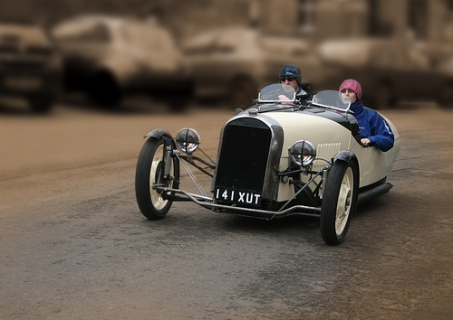
You need to know how to best control movement in your image to be a successful sports photographer. Your viewpoint is also key. At a racing circuit it is easier to photograph vehicles coming around a tight corner. They are moving more slowly, and the vehicle and the driver can look dramatic when completing a tight turn. However in this image the classic car is travelling much more slowly, and the photographer is able to capture all the detail.
A telephoto lens increases the size of the subject in the frame, and the large aperture has reduced the visual impact of the distracting background. In both situations you need to choose your viewpoint well in advance.

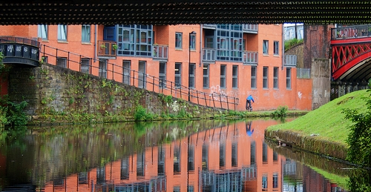
Architecture and landscapes offer a lot more freedom in selecting your viewpoint. Often the best viewpoints are found during the process of exploring the area. The image below has a colourful, almost childlike quality. The carefully chosen viewpoint illustrates how new aesthetic buildings can be successfully developed on brownfield sites; the two bridges provide the link with the past.
The leading lines emerging from the bottom corners of the frame take our eye immediately to the cyclist positioned two thirds of the way across the image. These converging lines generate a strong sense of perspective. The photographer has also created a series of triangles within the frame. Triangles are the most dynamic shape within an image and they always will always add impact to your photograph.
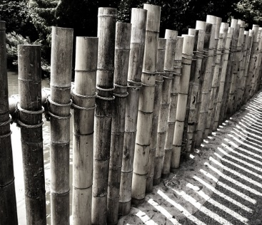
Maurice Wilson has emphasised the impact of lines, shapes and shadows by producing the image as a monochrome. A viewpoint slightly above the bamboo fence captures the shadows on the ground. The top of the fence stands out against its dark background. The subject fills the entire frame, adding to its impact.
The small lens aperture has maximised the depth of field so that the pattern created by the shadows repeats clearly throughout the image.

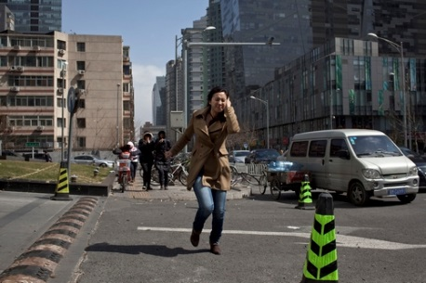
Hao Wu has generated a great sense of drama in his photograph. He took the image from just above street level.
This viewpoint increases the image’s tension, as does placing the subject in the centre of the frame. He’s also made the most of the strong
directional light to emphasise the anxiety in her face, all set against an urban Asian background. This has been produced to illustrate some of the tensions and challenges of modern urban life, whereas in reality she may have just been making a routine telephone call on a windy day.

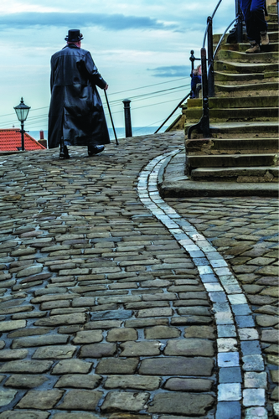
Sheila Haycox illustrates the importance of choosing the ideal viewpoint. The blue pavers at her feet take us immediately to the focal point of the image, the striking, Gothic styled figure looming above the horizon. Sheila has used a wide-angle lens in portrait mode to emphasise the beauty of the wet cobbled street, and she also placed her subject between two small vertical elements. The mood is enhanced by the rich, saturated colours. The power of the image is created primarily by the low viewpoint.
It would be wonderful if we could capture extraordinary photographs by chance, but in reality the majority of great photographs have required a lot of planning and preparation, as in this instance.

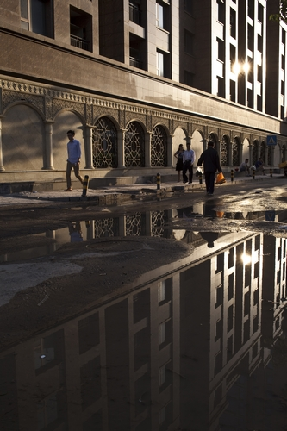
Architectural photographs of tall buildings often need to be taken when you are fairly close to them, how can you avoid converging verticals?
To reduce the effect, move back as far as possible, particularly wh en using a wide angle lens. Preferably move further back and use a telephoto lens. Try not to tilt your camera. You will need to capture as much detail as possible, so when hand holding select a fast shutter speed, 1/250 sec or more.
See if you can find a higher viewpoint to shoot from, may be the top of a building or a multi-storey car park. You can also straighten your verticals afterwards with photo editing software. Your images will be punchier if you use a tripod.

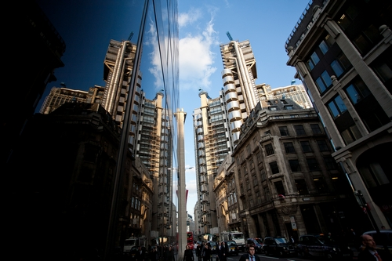
Some architectural photographers deliberately distort their image by exaggerating converging verticals. You need to get in close, and use your camera in portrait mode to capture extra height.
Slightly distorted verticals are distracting, but exaggerate them and the result is dramatic. The height of the building is emphasised and warped reflections add to the composition. A strong sky is key.

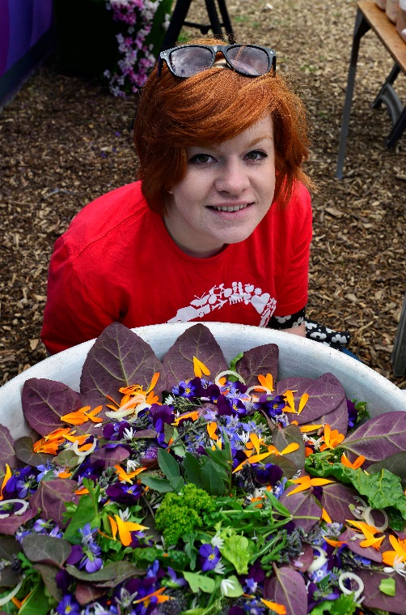
Portraits of children and pets are often taken by adults standing up. This viewpoint o diminishes the power of the subject, they appear submissive and vulnerable. So try shooting upwards at your subject. Compare these two shots. The child appears confident and relaxed, whereas the woman seems a little anxious.

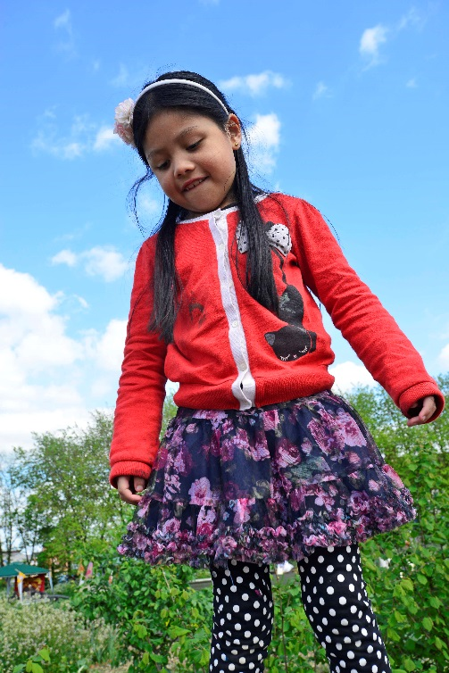
This effect is created by the angle of the camera, and how your model responds to you from the two different viewpoints.
Leading lines within a photograph help to draw the viewer’s attention to a specific element, or to tell a story as a journey. Are often used to strengthen landscape photographs. The photographer wants to connect the foreground to the centre of the image, and an open gate the winding track will have just this effect. There also useful in connecting separate elements within the frame, thereby generating shapes.
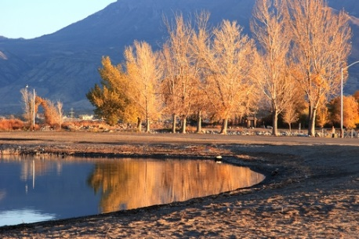
Many photographers use leading lines emerging from the left-hand side of the image. We read from left to right and this helps us to appreciate the image. In this photo Swapnali Mathkar has used the waters edge to take us into the centre of the photograph, and to emphasise the power of the reflected autumn colours.

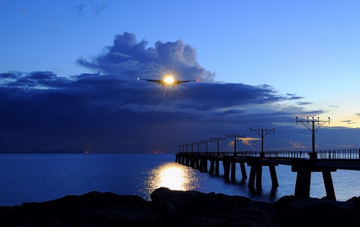
The leading lines from the right hand side of an image also help to increase its impact. In Leka Huie’s photo of an aircraft landing, a pier emerges from the bottom right-hand corner of the image. It takes our eye into the centre of the frame and highlights the link between the aircraft’s light and its reflection on the water. Her choice of viewpoint helped her to draw attention to the most important elements within the image.

